CHAPTER-1

**INTRODUCTION**



INDUSTRY PROFILE

FIBRE GLASS INDUSTRY

The Indian fiber glass industry market was valued at $779 million in2018 and a CAGR of

more than 8%to reach $1.2billion by 2024.

Anticipated growth in market can be attribute to the extensive use of fiberglass in the

construction and other industries. fiberglass refers to a strong, light weight material that

transformed into a woven layer or used as reinforcement.

**Types and forms of fiberglass:**

Depending on the raw materials used and their proportions to make fiberglass, fiberglass

can be classified into following major types:

* **A-glass**: A glass is also called as alkali glass and is resistant to chemicals. Due to the

composition of A glass fiber, it is close to window glass. In some parts of the world, it is used to make process equipment.

* **C-glass**: C-glass offers very good resistance to chemical impact and is also called as

chemical glass.

* **E-glass**: It is also called as electrical glass and is a very good insulator of electricity.
* **AE-glass**: This is alkali resistant glass.
* S glass: It is also called as structural glass and is known for its mechanical properties.

**Fiberglas comes in various forms to suite various applications, the major ones being:**

* **Fiberglas Tape**: fiberglass tapes are made up of glass fiber yarns and are known for their thermal insulation properties. This form of fiberglass finds wide applications in wrapping vessels, hot pipelines, and the likes.
* **Fiberglas Cloth**: fiberglass cloth is smooth and is available in various variants like glass fiber yarns and glass filament yarns. It is widely used as heat shields, in fire curtains and others.
* Fiberglas Rope: Ropes are braided from glass fiber yarns and are used for packing

purposes.

**Properties of fiberglass**

* Mechanical strength: fiberglass has a specific resistance greater than steel. So, it is used to make high-performance
* Electrical characteristics: fiberglass is a good electrical insulator even at low thickness.
* Incombustibility: Since fiberglass is a mineral material, it is naturally incombustible. It does not propagate or support a flame. It does not emit smoke or toxic products when exposed to heat.
* Dimensional stability: fiberglass is not sensitive to variations in temperature and

hygrometry. It has a low coefficient of linear expansion.

* Compatibility with organic matrices: fiberglass can have varying sizes and has the ability to combine with many synthetic resins and certain mineral matrices like cement.
* Non-rotting: fiberglass does not rot and remains unaffected by the action of rodents and insects.
* Thermal conductivity: fiberglass has low thermal conductivity making it highly useful in the building industry.
* Dielectric permeability: This property of fiberglass makes it suitable for electromagnetic windows.

**Applications of fiberglass in various Industries**

Materials with high-temperature insulation provide an effective thermal barrier for

industrial gaskets. Since fiberglass is durable, safe and offers high thermal insulation,

fiberglass is one of the widely preferred materials in industrial gaskets. They not only

provide a better insulation but also help in protecting the machinery, conserving the energy

and ensure the safety of the professional workforce. This is the reason perhaps why

fiberglass is widely used in industries given below:

• Beverage industry: fiberglass grating is used in many areas like bottling lines and in brew

houses.

• Car washes: Recently, fiberglass grating is greatly used for rust resistance and to give a

contrast color to areas that previously looked forbidden. It brightens the inside of the

carwash tunnel making the car look cleaner than it was.

• Chemical industry: In this industry, the fiberglass grating is used for anti-slip safety feature

of the embedded grit surface and the chemically resistant feature of different resin

compounds. The chemicals being used are matched with the resins.

• Cooling towers: Since cooling towers are always wet, they have to be protected from rust,

corrosion, and other safety issues. Due to the excellent properties of fiberglass, it is used in

these towers as screening to keep people and animals away from the danger zones.

• Docks and marinas: The docks get corroded, rusted and damaged by the salty sea water.

So, fiberglass is used here for protection.

• Food processing: In the chicken and beef processing plants, fiberglass grating is used for

slip resistance and for holding up to blood which is corrosive. Most of the areas of food

processing also use fiberglass as other grating materials are not suitable.

• Fountains and aquariums: All sizes of fountains and aquariums use fiberglass to support

rocks to help in circulation and filtering from under the rocks. In large public fountains,

fiberglass grating is used to protect spray headers and lights from getting damaged. This

also keeps people from drowning in the fountains.

• Manufacturing: The embedded grit surface of fiberglass grating ensures slip resistance in

the areas that are wet or in places where hydraulic fluids or oils are present.

• Metals and mining: fiberglass grating is used in electronic refining areas prone to chemical

corrosion. Other grating materials cannot be used here.

• Power generation: Many areas of the power generation industry like tank farms, scrubbers,

and others use fiberglass. The reason for this is the non-conductive property of fiberglass.

• Plating plants: This application uses fiberglass grating due to the anti-slip property of the

surface.

• Pulp and paper industry: The property of fiberglass which makes it chemical corrosion

resistant is useful in pulp and bleach mills. Recently, fiberglass is used in many areas due to

its corrosion resistance and anti-slip properties.

• Automotive industry: fiberglass is extensively used in automobile industry. Almost every

car has fiberglass components and body kits.

• Aerospace & Defense: fiberglass is used to manufacture parts for both military and civilian

aerospace industry including test equipment, ducting, enclosures, and others.

**HISTORY OF FIBRE GLASS INDUSTRY**

Glass fibers have been produced for centuries, but the earliest patent was awarded to the

Prussian inventor “Hermann Himmelfarb” (1845-1914) in the U.S in 1880.

**TOP FIBRE GLASS INDUSTRIES OF INDIA**

1. FIBROTECHNIC-MUMBAI

2. NEW FIBRE HOUSE-PUNJAB

3. VIJAY TRADERS-BANGALORE

4. INDUSMATRIX INDIA PRIVATE LIMITED-GHAZIBAD

5. AASTHA FIBRE AND CHEMICALS –JAIPUR

6. KAMPUN POLYMERS-PARDI

7. SVSS REINFORCEMENT-VISKHAPATANAM

8. SUPREME PLASTIC FABRICATORS-VAPI

9. MARCURS PVT-PUNE

10. INDUSTRIAL TAPES AND FABRICS -KOLKAT

**SOME OF THE PRODUCTS OF FIBRE GLASS INDUSTRIE**

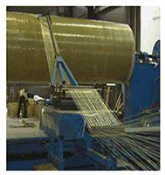



**COMPANY PROFILE**

**SUNRISE FIBRE GLASS INDUSTRIES, BANGALORE**

**Sunrise fiber glass industry, Bangalore is one of the leading frap manufacture industries in and around the Bangalore. And it is showing a major improvement in all of it fields nowadays and now it is also a competitor for other industries.**

**Sunrise fraps manufactures quality products in fiberglass composites (EPOXY) especially rod, nut, sheets, and pultrude sections of desired sizes required by our customers. They also provide wide range of Filament winding process –tube, pipe, cylinders and other electrical insulators foe heavy electrical sectors**

|  |  |
| --- | --- |
| **Descriptions** | **Details** |
| **Company name** | **SUNRISE FIBRE GLASS INDUSTRIES** |
| **Nature of job** | **Manufactures of frap electrical insulator, pultrude and sections, filament wind tube etc.** |
| **Company register**  **Place** | **Bangalore** |
| **GSTIN no** | **29AELPS6045N1ZM** |
| **Company type** | **PROPRIERSHIP** |
| **Contact no** | **MR. Ashok raj gowda** |
| **Contact no** | **9341042275** |
| **Email** | **frpinsulatora@gmail.com** |

**COMPANY UTILIZATION**

|  |  |  |
| --- | --- | --- |
| **SL.NO** | **Machinery Name** | **NO’S** |
| **1** | **Pultrusion (for FRP rods)** | **3** |
| **2** | **Filament winding CNC** | **3** |
| **3** | **Hot press for laminating** | **1** |
| **4** | **Turning (lathe)machines** | **27** |
| **5** | **Centre less grinding machine** | **1** |
| **6** | **DG set** | **1** |
| **7** | **Drilling machine** | **1** |
| **8** | **Milling machine** | **1** |
| **9** | **Oven (for curing & post curing)** | **1** |
|  | **Well-equipped house laboratory for conducting test like high voltage, specific gravity, glass content, water absorption, water diffusion test, tube pressure test and other dimensional test equipment’s**  **Total area of constructed: 35000sqft.** |  |

**LIST OF SFGI CLIENTS**

* **Bharat Heavy Electricals Limited**
* **ABB INDIA**
* **Crompton Greaves**
* **ISRO**
* **Bharat Electrical**
* **Power Grid Corporation Limited**
* **NTPC**
* **Aditya Birla**
* **Toshiba transmission**
* **Obum Electricals**

**SUNRISE FIBRE GLASS INDUSTRY PRODUCTS:**

1. PULTRUDED PROFILES
2. FILAMENT WIND COMPONENTS
3. LAMINATED SHEETS

**A. PULTRUDED PROFILES**

SUNPUL

Applications:

Studs for Lightening Arresters, Selector Bars for Tap Changers.

'I' Sections & Rods for Gratings, 'C' Channels & 'L' Angles for Cable Ladders/Trays.

Drive Links, Switching Bars, Tension Plates for Switchgears, Rods for Composite Insulators

Duct Strips, Dovetail Strips & spacers, Dog Bone Profiles, 'U' Profiles, and Hat Profiles For oil cooled & dry type Transformers.

**Advantages:**

The profiles produced with this process can compete with traditional metal profiles such as

steel and aluminum for strength and weight.

The polymer-reinforced matrix can be formulated to meet the most demanding chemical,

flame retardant, electrical and environmental conditions.

Pultrusion brings high performance composites down to commercial products such as

lightweight corrosion free structures, electrical non-conductive systems, offshore platforms,

road and railway trucks, and many other innovative new products.

B**. FILAMENT WIND COMPONENTS**

SUNWIND

Applications:

Tubes for Lightening Arresters. OLTC Tanks & Hollow Shafts. Selector Column, Switch

pillars, Centering Tubes for Tap-Changers.

Fuse bodies for low & medium voltages. End Rings/Edge Blocks for transformers 11 KV to

400 KV applications.

Coil formers 11 KV to 220 KV applications. Insulating Tubes for transformers. Rupturing

Chambers, Arc pots for switchgears.

Insulating rods & Operating rods (hollow) for low voltage, medium voltage & high voltage

for vacuum circuit breakers, SF6 circuit switchgears.

Product Range:

Tubes from ID 12mm to 1600 mm, Wall thickness from 0.8 mm to 100 mm Length of tube

up to 6.5Mtrs.

Advantages

Filament winding is a versatile technique for composites fabrication suited for axially

components such as cylindrical pressure vessels, pipelines, cylinders for storage of high

pressure gases, rocket motor casings, large underground storage tanks and electrical

applications.

Apart from strength to weight advantages and low cost of manufacturing, filament wound

composite parts have better corrosion and electrical resistance

**C. FRP LAMINATED SHEETS**

Based on epoxy resins and fiber glass reinforcement, various grades of laminates are

manufactured and trader to.

NEMA G-10 and G-11 standards, With the requirement of high tracking resistance and high

di-electric strength. Special type laminates are offered for MV Panels and Breakers. These

are available in standard size in thickness rang of 0.8 mm - 20mm (size: 1mtr X 1mtr)

**PRODUCTS OF SUNRISE FIBRE GLASS INDUSTRY**

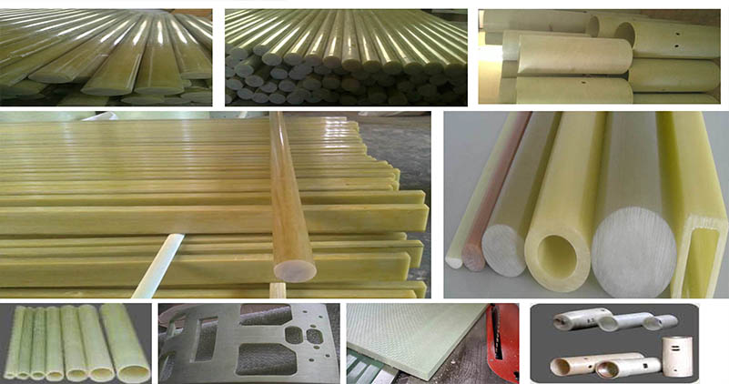

**CHAPTER -2**

**INTRODUTION TO TOPIC**

**CUSTOMER SATISFACTION**

Customer satisfaction is defined as measurement that determines how happy customer are services, capabilities. Customer satisfaction information, including surveys and can help a company determine how to best improve or changes its products and services.

An organization’s main focus must be to satisfy its customers. This applies to industrial firms, service wholesale business, government bodies, nonprofit organization, and every subgroup within an organization.

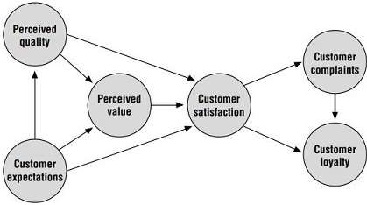

customer satisfaction (CSAT) is a measure of how well a company’s products and services meet customers’ expectations. It reflects your business’

health by showing how well your products is resonating with buyers**.**

**How to measure customer satisfaction**

Customer satisfaction can seem like a vague concept, but there are concrete ways to measure it. You can source a customer satisfaction score by conducting CSAT surveys, forexample. These are typically short, one- to two-question surveys offered at the end of a business transaction. A classic question is “How satisfied are you with the product?” with answers ranging from “very satisfied” to “very unsatisfied.”

Although CSAT is one part of customer satisfaction, it is far from the only measure. Businesses also use Net Promoter Score (NPS) surveys to determine whether their customers are promoters, detractors, or passives.

**Customer satisfaction vs. customer loyalty**

Warning: Do not confuse customer satisfaction with customer loyalty. They are intimately linked, but there is a difference between the two concepts.

Customer satisfaction measures how happy a customer was with a support interaction or a purchase. Customer loyalty, on the other hand, is an ongoing state. Loyal customers give a company their repeat business over time. It’s not a short-term measure, but rather a long-term understanding of the health of your customer relationship.

When you create and maintain a customer experience that resonates with buyers, customers return again and again. Ensuring high customer satisfaction in the short term is a key component of gaining that long-term customer loyalty.

**Why is customer satisfaction important?**

Customer satisfaction is important because it means your customer base likes what you are doing. Research shows that customer satisfaction leads to greater customer retention, higher lifetime value and a stronger brand reputation.

**5 reasons customer satisfaction is important**

 Customer loyalty

 Customer satisfaction measurement

 Repeat purchases

 Customer lifetime value

 New customer acquisition1.

1. **Customer loyalty**

Satisfied customers tend to share their positive experiences with friends and family. But the opposite is also true: An unhappy customer tells more people about their negative experiences than a happy customer does.

Social media makes social proof more powerful than ever before, with 79 percent of people in the United States using social media to connect and share their experiences. Today, a customer can easily share feedback on a bad experience with millions of people with a single click (so make sure that review is going to be a positive one).

You are more likely to gain positive referrals if you use customer feedback to priorities top-of-the-line service. For example, our report found that 89 percent of people think quick responses are important when deciding which company to buy from. If you want to improve your company’s response time to support that data, you might incorporate AI technology, like our AI-powered Answer Bot, to send prompt responses.

**2. Customer satisfaction metrics reflect your support team's performance**

Customer satisfaction benchmarks and metrics do not just help you gauge how happy your audience is they also tell you how your support team is doing. Use a variety of team metrics to understand customer satisfaction levels:

 Your support team’s initial response time: In our customer experience report, the #1 most frustrating part of bad service was long waiting times. Faster support team response times not only lower customer frustration, but also give you a measure of your team’s speed and efficiency.

 The length of time it takes your team to resolve a customer issue: If it is taking your team hours to resolve issues that could be dealt with quickly, it might be time to tweak your internal processes. Do not just strive to respond quickly—resolve quickly, too.

 How many times a ticket or call required a transfer to find a resolution: Few things are more frustrating than having to wait to be transferred to a new agent and repeat your issue to get your request completed. If transfer occurrence drops, customer satisfaction should rise.

Considering our study found that the #1 aspect for good customer service was quick issue resolution, your team’s efficiency in these areas says a lot about customer satisfaction. Our built-in analytics function is a great way to observe how well your support team serves customers historically and in real time. With the help of AI, teams can even predict customer satisfaction during a conversation—before a customer takes a survey.

**3. It encourages repeat purchases**

A satisfied customer is a loyal customer, who will stick with your company year after year. So, how do you get those repeat customers? By hitting your customer support efforts out of the park. Our trends report agrees: 57 percent of consumers say excellent customer service is a factor in their brand loyalty.

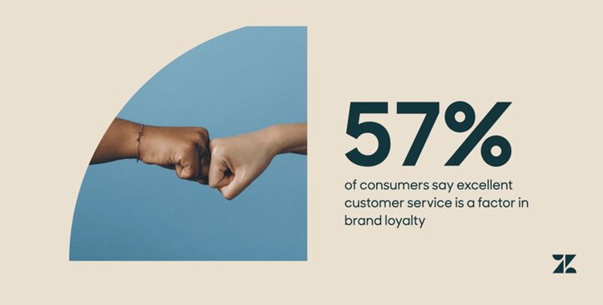

How do you know if your customer service is driving customer loyalty? There are two different ways to answer this question. The first is to directly poll customers using a net promoter score survey, or to ask questions like:

* “Would you speak to your friend about our brand?”
* “How often do you speak to your friends about our brand?”

These questions can shed some light on customers’ likelihood of being brand ambassadors.

The second method is to observe customer behavior. For example, you can track repeat purchases with loyalty programs and referral posts for your business on social media. Reading conversations in your community forum can also give your insight into how customers feel about their experience with your product or service.

**4. It increases customer lifetime value**

75 percent of customers are willing to spend more to buy from companies that give them a good customer experience, according to our Trends Report. Satisfied customers are not only more likely to remain loyal and less likely to churn, they are also more likely to spend more money with your business.



In fact, during the first 6 months of the COVID-19 pandemic, those companies that had the highest CSAT scores were 8.7x more likely to have significantly grown customer spend.

**5. It boosts new customer acquisition**

At the onset of the pandemic, companies with the most satisfied customers were also 3.3x more likely to have grown their customer bases. Customer service is not just important for supporting existing customers, it is also key to bringing in potential customers and supporting them when they reach out. If a prospect does not have a positive experience when they interact with your support team, they will be less likely to purchase. The main difference between service today and service 10 years ago is that customers expect premium service to be built-in from the first sales or marketing interaction and carry through to the moment they ask for help, post-purchase and back again. To position themselves for success, businesses must integrate service into the journey at every interaction point.

**How do you achieve customer satisfaction?**

The benefits of focusing on customer satisfaction are clear. But actually, making customers happy can take some trial and error. The key is persistence. Always aim to go above and beyond for customers, and lean on other departments to help boost your customer experience.

**How to improve customer satisfaction**

* Customer feedback
* Convenience
* Speed.
* Build a customer-focused culture
* Empathy

**1. Become obsessed with customer feedback**

Become a student of your customer feedback. Do not just collect it: Analyses it and apply it to what your customers are saying. Commit to learning about buyers’ pain points and then make a plan to alleviate them in ways that set you apart from competitors.

A great way to do this is to use Zendesk’s feedback feature. The tool includes analytics for agent performance and customer surveys, so you can study complaints and compliments regarding your services.

Even without a CRM like Zendesk, you can still keep close tabs on customer feedback. Social media and online review boards are especially good places to monitor buyer attitudes. Search for mentions of your brand name or your dedicated hashtags on social sites to see what people are saying.

**2. Create a sense of convenience**

The most successful physical stores are all about buyer convenience. Customers enjoy places with flexible hours that fit their schedules. Think of the success Walmart, 24-hour drug stores and gas stations have with that model. We are also more likely to shop at places close to us.

To build the same sense of convenience as a brick-and-mortar store online, you need to have a digital presence on the platforms and services your customers already use. Use SEO-optimized blog posts and social content to be front and center in Google searches and social media feeds. And make a point to be easily accessible for support questions on your customers’ channels of choice.

Offering support via messaging apps (like WhatsApp, Twitter and Facebook) helps businesses create that same sense of 24-hour availability. These are the same channels customers use to interact with friends and family, so it gives you a chance to meet them where they already are.

You should also offer opportunities for customers to help themselves. Many customers prefer the hands-off convenience of a knowledge base, where they can search for information without having to interact with customer support reps.

**3. Deliver fast responses**

In our Trends Report, we asked customers what matters most to them when resolving an issue with a company. 73 percent said "they resolve my issue quickly" and 59 percent said "they respond quickly." In a constantly connected world, customers don't want to have to wait a day or even more than a few hours, for a response. Here are some tips for delivering faster responses:

* Pre-written responses ensure agents do not have to write common answers repeatedly
* Messaging channels enable agents to help more customers at once because they are asynchronous. In fact, support teams that have the fastest resolution times are 42 percent more likely to be messaging with their customers.
* AI-powered bots can intercept would-be tickets when agents are off the clock
* Bots can also gather details upfront, such as city or account type, before an agent takes over

**4. Make customer satisfaction a company-wide focus**

To improve overall customer satisfaction, you have to put time and effort into a business strategy that puts customers first.

Using a tool like the balanced scorecard is a great first step. The balanced scorecard guides companies in thinking about their operations from four different perspectives:

* Financial
* Internal business
* Customer
* Innovation and learning

It also helps companies consider how all their activities are working toward the goal of high customer satisfaction.

The balanced scorecard is just one way to incorporate customer satisfaction into company goals. You can (and should) incorporate customer satisfaction into your company mission and value proposition, too. That keeps it top-of-mind with every employee, regardless of their position.

**5. Lead with empathy**

If there is one thing the pandemic taught us, it’s that empathy is an essential skill for support professionals— it is even more valuable than customer service experience. In fact, nearly half of customers want to interact with an empathetic customer service representative. Support leaders can provide empathy training, but it is also a good idea to hire support reps who can already put themselves in an angry customer’s shoes and communicate that understanding to the customer. Businesses might also consider allowing agents to make exceptions to certain policies in situations that require empathy.

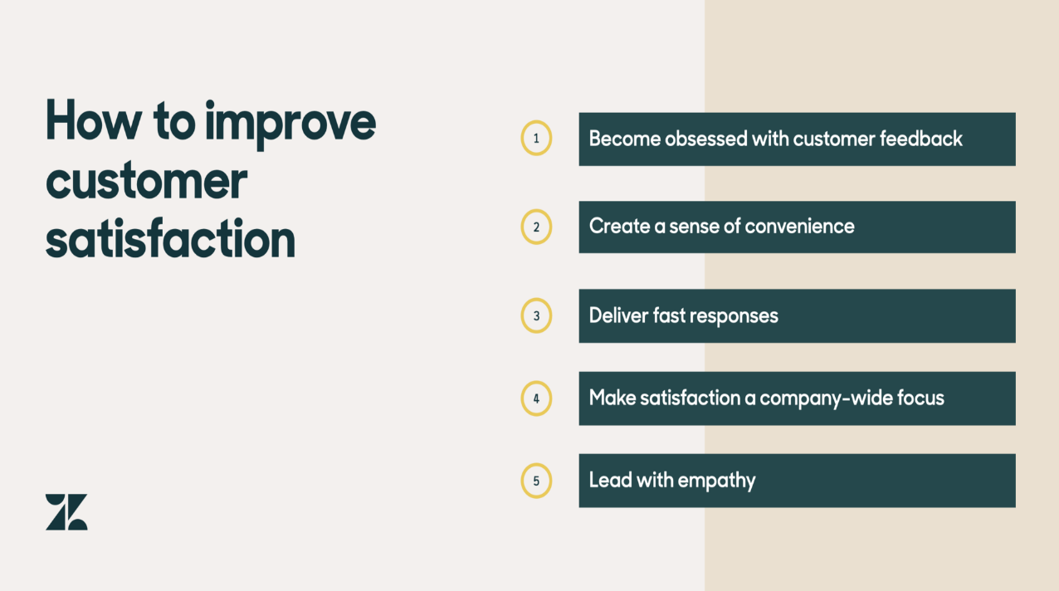

**4 key customer satisfaction metrics to track**

Here are 4 key customer satisfaction measurements that are critical to your business success. They take into account the different dimensions of customer satisfaction, such as affective (emotional) and cognitive (rationally judged) reactions to a product or service and behavioral intentions (such as likelihood to recommend or repurchase) as well as taking overall scores of satisfactions as judged by the respondents.

1. **Overall Satisfaction Measure (Attitudinal**)

This question reflects the overall opinion of a consumer’s satisfaction experience with a product he or she has used.

The single greatest predictors of customer satisfaction are the customer experiences that result in attributions of quality.

Perceived quality is often measured in one of three contexts:

* Overall quality
* Perceived reliability
* Extent of customer’s needs fulfilled

It is commonly believed that dissatisfaction is synonymous with purchase regret while satisfaction is linked to positive ideas such as “it was a good choice” or “I am glad that I bought it.”

By using the perception of quality and product satisfaction as a guide, we can better measure customer satisfaction as a whole.

1. **Customer Loyalty Measurement (Affective, Behavioral)**

This single-question measure is the core NPS (Net Promoter Score) measure.

Customer loyalty reflects the likelihood of repurchasing products and services. Customer satisfaction is a major predictor of repurchase but is strongly influenced by explicit performance evaluations of product performance, quality, and value.

Loyalty is often measured as a combination of measures including overall satisfaction, the likelihood of repurchase, and the likelihood of recommending the brand to a friend (as measured by Net Promoter Score).

A common measure of loyalty might be the sum of scores for the following three questions:

* Overall, how satisfied are you with [brand]?
* How likely are you to continue to choose/repurchase [brand]?
* How likely are you to recommend [brand] to a friend or family member?

Understanding customer loyalty in this form of metric helps you to measure customer satisfaction from the angle of future behavior. It can be helpful not only for understanding customer satisfaction now but also for developing future purchase predictions.

1. **A series of Attribute Satisfaction Measurements (Affective and Cognitive)**

Affect (liking/disliking) is best measured in the context of product attributes or benefits. Customer satisfaction is influenced by the perceived quality of product and service attributes and is moderated by expectations of the product or service. The researcher must define and develop measures for each attribute that is important for customer satisfaction**.**

Consumer attitudes toward a product developed as a result of product information or any experience with the product, whether perceived or real.

Again, it may be meaningful to measure attitudes towards a product or service that a consumer has never used, but it is not meaningful to measure customer satisfaction when a product or service has not been used.

1. **Intentions to Repurchase Measurements (Behavioral Measures)**

When wording questions about future or hypothetical behavior, consumers often indicate that “purchasing this product would be a good choice” or “I would be glad to purchase this product.” Behavioral measures also reflect the consumer’s past experience with customer service representatives.

Customer satisfaction can influence other post-purchase/post-experience actions like communicating to others through word of mouth and social networks.

Additional post-experience actions might reflect heightened levels of product involvement that in turn result in an increased search for the product or information, reduced trial of alternative products, and even changes in preferences for shopping locations and choice behavior.

**7 steps to improve customer satisfaction rates**

Beyond avoiding these pitfalls, where should you start to improve your CSAT scores?

Adapt our seven-step customer satisfaction roadmap to your unique business and product to get on the right track to higher customer satisfaction:

**Step 1: define your goals**

Before you start implementing changes on your website or product, define what goals your company is trying to accomplish. Get as granular as possible: as well as targeting a higher CSAT, focus on other customer satisfaction goals, like lower average response time, lower number of touchpoints, etc.

Defining your goals helps guide the areas of focus for your organization and where you should start focusing your energy when making product improvements.

**Step 2: identify current obstacles to customer satisfaction**

Where are your customers’ pain points? Where do they bounce from your site or stop scrolling? What makes them churn or resist new features or upgrades? What frustrates them about your customer service or support?

Understanding what’s blocking customer delight is key to defining your areas of improvement. For example, if your main issue is a long wait time for support, shift company resources to streamlining those channels and even adding more staff. If your customers are dissatisfied because they’re struggling to find information on your site, prioritize UX improvements to navigation.

**Step 3: use the right tools to help measure success**

Building your tech stack with tools that helps you understand and analyze user behavior and measure success is a great way to validate your ideas when making product changes.

Hotjar’s Observe tools—Heatmaps and Recordings—help you visualize user behavior and see firsthand what your customers are experiencing. With Ask tools such as Feedback and Surveys, send out CSAT surveys with space for extra information to help you understand why customers are (or aren’t) satisfied, and whether the changes you’ve made are having a positive effect on customer satisfaction.

**Step 4: implement changes and gather more data**

Once you’ve implemented product or website changes, set aside time to gather and analyze data to get to the root causes of customer roadblocks. Measure customer satisfaction metrics like average ratings, net promoter score®(NPS), customer effort score (CES), bounce rates, and more. Are a large number of customers experiencing bugs? Long wait times? Once you figure out if the changes you made are having the expected impact on your customer satisfaction, you’ll be able to either continue on the same path or switch direction.

**Step 5: improve customer support**

Customer support is an important touchpoint for customer satisfaction, and you should always be taking steps to improve the support experience.

Identify areas of frustration in your current support process, and prioritize improvements—whether that means updating help documentation, adding a chatbot, or investing in more support staff.

**Step 6: prioritize post-purchase follow-up**

Continuing to communicate with your customers after they make a purchase or download is a great way to build a solid product experience and relationship with users. Send them a thank-you email, ask them for feedback to improve the process, and suggest other products or features they may be interested in.

Keep your post-purchase communications friendly, clear, and concise, and adapt them to the channels your customers use most, whether that’s email, social media, or a messaging service. Gather data with your preferred tools and test what works best for your product and your customers.

**Step 7: listen to your customers**

Regularly collecting customer feedback is the best way to check how your business is performing and identify gaps or opportunities for improvement. Giving customers the opportunity to express themselves opens the door to conversations about what customers want, and ultimately helps you create a better product.